Daniel Martinez

CS 231

Email: marti931@cougars.csusm.edu

1)

Truth Table:

|  |  |  |  |  |  |
| --- | --- | --- | --- | --- | --- |
| x | y | z | a | b | c |
| 0 | 0 | 0 | 0 | 0 | 1 |
| 0 | 0 | 1 | 0 | 1 | 0 |
| 0 | 1 | 0 | 0 | 1 | 1 |
| 0 | 1 | 1 | 1 | 0 | 0 |
| 1 | 0 | 0 | 0 | 1 | 1 |
| 1 | 0 | 1 | 1 | 0 | 0 |
| 1 | 1 | 0 | 1 | 0 | 1 |
| 1 | 1 | 1 | 1 | 1 | 0 |

K-Maps:

|  |  |  |  |  |
| --- | --- | --- | --- | --- |
| a | 00 | 01 | 11 | 10 |
| 0 | 0 | 0 | 1 | 0 |
| 1 | 0 | 1 | 1 | 1 |

a = xy + xz + yz

|  |  |  |  |  |
| --- | --- | --- | --- | --- |
| b | 00 | 01 | 11 | 10 |
| 0 | 0 | 1 | 0 | 1 |
| 1 | 1 | 0 | 1 | 0 |

= xy’z’ + xyz + x’y’z + x’yz’

= x(yz + y’z’) + x’(yz’ + y’z)

b = x(y $⊕$ z)’ + x’(y $⊕$ z)

|  |  |  |  |  |
| --- | --- | --- | --- | --- |
| c | 00 | 01 | 11 | 10 |
| 0 | 1 | 0 | 0 | 1 |
| 1 | 1 | 0 | 0 | 1 |

c = z’

a = xy + xz + yz

b = x(y $⊕$ z)’ + x’(y $⊕$ z)

c = z’

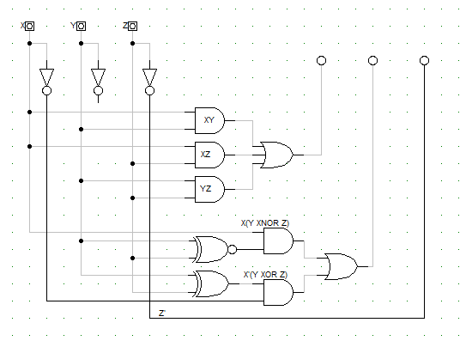

2)

|  |  |  |  |  |  |  |  |
| --- | --- | --- | --- | --- | --- | --- | --- |
| a | b | c | d | w | x | y | z |
| 0 | 0 | 0 | 0 | 0 | 0 | 0 | 0 |
| 0 | 0 | 0 | 1 | 1 | 1 | 1 | 1 |
| 0 | 0 | 1 | 0 | 1 | 1 | 1 | 0 |
| 0 | 0 | 1 | 1 | 1 | 1 | 0 | 1 |
| 0 | 1 | 0 | 0 | 1 | 1 | 0 | 0 |
| 0 | 1 | 0 | 1 | 1 | 0 | 1 | 1 |
| 0 | 1 | 1 | 0 | 1 | 0 | 1 | 0 |
| 0 | 1 | 1 | 1 | 1 | 0 | 0 | 1 |
| 1 | 0 | 0 | 0 | 1 | 0 | 0 | 0 |
| 1 | 0 | 0 | 1 | 0 | 1 | 1 | 1 |
| 1 | 0 | 1 | 0 | 0 | 1 | 1 | 0 |
| 1 | 0 | 1 | 1 | 0 | 1 | 0 | 1 |
| 1 | 1 | 0 | 0 | 0 | 1 | 0 | 0 |
| 1 | 1 | 0 | 1 | 0 | 0 | 1 | 1 |
| 1 | 1 | 1 | 0 | 0 | 0 | 1 | 0 |
| 1 | 1 | 1 | 1 | 0 | 0 | 0 | 1 |

Truth Table:

K-Maps:

|  |  |  |  |  |
| --- | --- | --- | --- | --- |
| w | 00 | 01 | 11 | 10 |
| 00 | 0 | 1 | 1 | 1 |
| 01 | 1 | 1 | 1 | 1 |
| 11 | 0 | 0 | 0 | 0 |
| 10 | 1 | 0 | 0 | 0 |

w = a’b + a’d + a’c + ab’c’d’

|  |  |  |  |  |
| --- | --- | --- | --- | --- |
| x | 00 | 01 | 11 | 10 |
| 00 | 0 | 1 | 1 | 1 |
| 01 | 1 | 0 | 0 | 0 |
| 11 | 1 | 0 | 0 | 0 |
| 10 | 0 | 1 | 1 | 1 |

x = bc’d’ + b’d + b’c

|  |  |  |  |  |
| --- | --- | --- | --- | --- |
| y | 00 | 01 | 11 | 10 |
| 00 | 0 | 1 | 0 | 1 |
| 01 | 0 | 1 | 0 | 1 |
| 11 | 0 | 1 | 0 | 1 |
| 10 | 0 | 1 | 0 | 1 |

= c’d + cd’

y = c $⊕d$

|  |  |  |  |  |
| --- | --- | --- | --- | --- |
| z | 00 | 01 | 11 | 10 |
| 00 | 0 | 1 | 1 | 0 |
| 01 | 0 | 1 | 1 | 0 |
| 11 | 0 | 1 | 1 | 0 |
| 10 | 0 | 1 | 1 | 0 |

z = d

w = a’b + a’d + a’c + ab’c’d’

x = bc’d’ + b’d + b’c

y = c $⊕d$

z = d

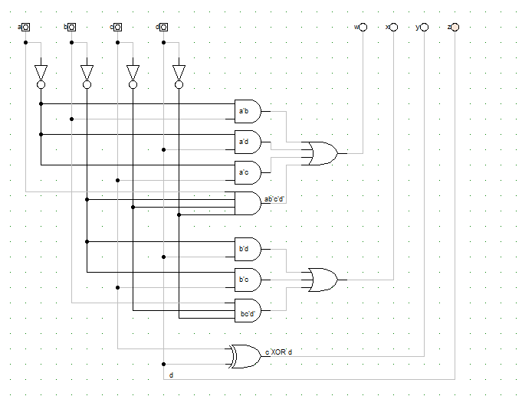

3)

Q’(t+1) = J’Q’ + KQ

State Table:

|  |  |  |  |  |
| --- | --- | --- | --- | --- |
| Q | J | K | Q(t+1) | Q’(t+1) |
| 0 | 0 | 0 | 0 | 1 |
| 0 | 0 | 1 | 0 | 1 |
| 0 | 1 | 0 | 1 | 0 |
| 0 | 1 | 1 | 1 | 0 |
| 1 | 0 | 0 | 1 | 0 |
| 1 | 0 | 1 | 0 | 1 |
| 1 | 1 | 0 | 1 | 0 |
| 1 | 1 | 1 | 0 | 1 |

K-Maps:

|  |  |  |  |  |
| --- | --- | --- | --- | --- |
| Q’(t+1) | 00 | 01 | 11 | 10 |
| 0 | 1 | 1 | 0 | 0 |
| 1 | 0 | 1 | 1 | 0 |

Q’(t+1) = J’Q’ + KQ

4)

A(t+1) = x’y + xA

B(t+1) = x’B + xA

z = B

A)

Logic Diagram of Circuit:

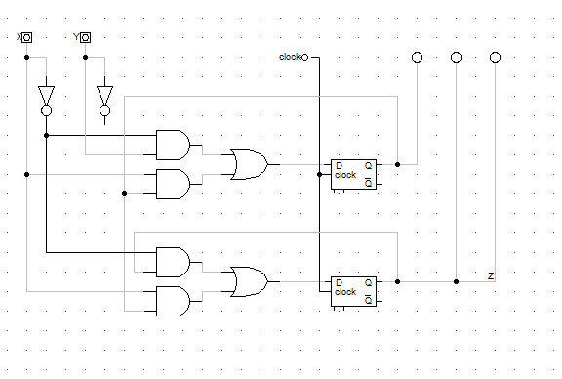

B)

State Table:

|  |  |  |  |  |  |  |  |  |
| --- | --- | --- | --- | --- | --- | --- | --- | --- |
| X | Y | A(t) | B(t) | A(t+1) | B(t+1) | Da | Db | Z |
| 0 | 0 | 0 | 0 | 0 | 0 | 0 | 0 | 0 |
| 0 | 0 | 0 | 1 | 0 | 1 | 0 | 1 | 1 |
| 0 | 0 | 1 | 0 | 0 | 0 | 0 | 0 | 0 |
| 0 | 0 | 1 | 1 | 0 | 1 | 0 | 1 | 1 |
| 0 | 1 | 0 | 0 | 1 | 0 | 1 | 0 | 0 |
| 0 | 1 | 0 | 1 | 1 | 1 | 1 | 1 | 1 |
| 0 | 1 | 1 | 0 | 1 | 0 | 1 | 0 | 0 |
| 0 | 1 | 1 | 1 | 1 | 1 | 1 | 1 | 1 |
| 1 | 0 | 0 | 0 | 0 | 0 | 0 | 0 | 0 |
| 1 | 0 | 0 | 1 | 0 | 0 | 0 | 0 | 1 |
| 1 | 0 | 1 | 0 | 1 | 1 | 1 | 1 | 0 |
| 1 | 0 | 1 | 1 | 1 | 1 | 1 | 1 | 1 |
| 1 | 1 | 0 | 0 | 0 | 0 | 0 | 0 | 0 |
| 1 | 1 | 0 | 1 | 0 | 0 | 0 | 0 | 1 |
| 1 | 1 | 1 | 0 | 1 | 1 | 1 | 1 | 0 |
| 1 | 1 | 1 | 1 | 1 | 1 | 1 | 1 | 1 |

C)

State Diagram:

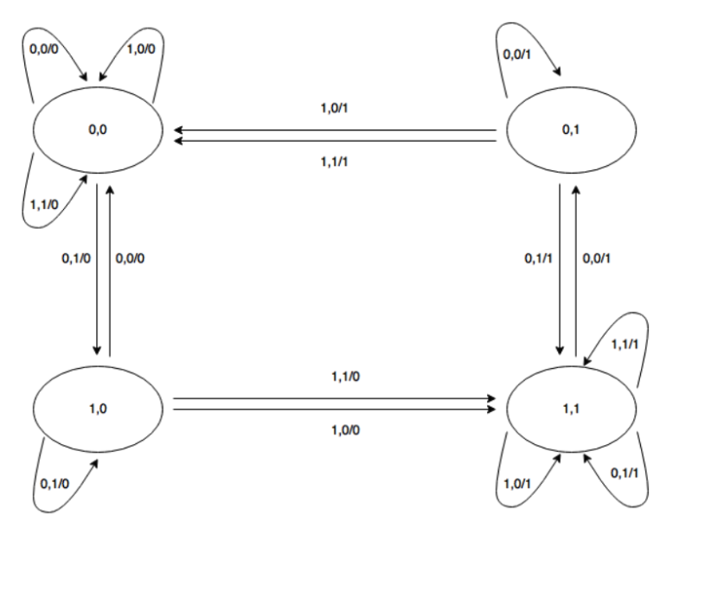

5)

State Table:

|  |  |  |  |  |  |
| --- | --- | --- | --- | --- | --- |
| A(t) | B(t) | A(t+1) | B(t+1) | Ta | Tb |
| 0 | 0 | 0 | 1 | 0 | 1 |
| 0 | 1 | 1 | 0 | 1 | 1 |
| 1 | 0 | 0 | 0 | 1 | 0 |
| 1 | 1 | 0 | 0 | 1 | 1 |

Ta = A + B

Tb = A’ + B

State Diagram:

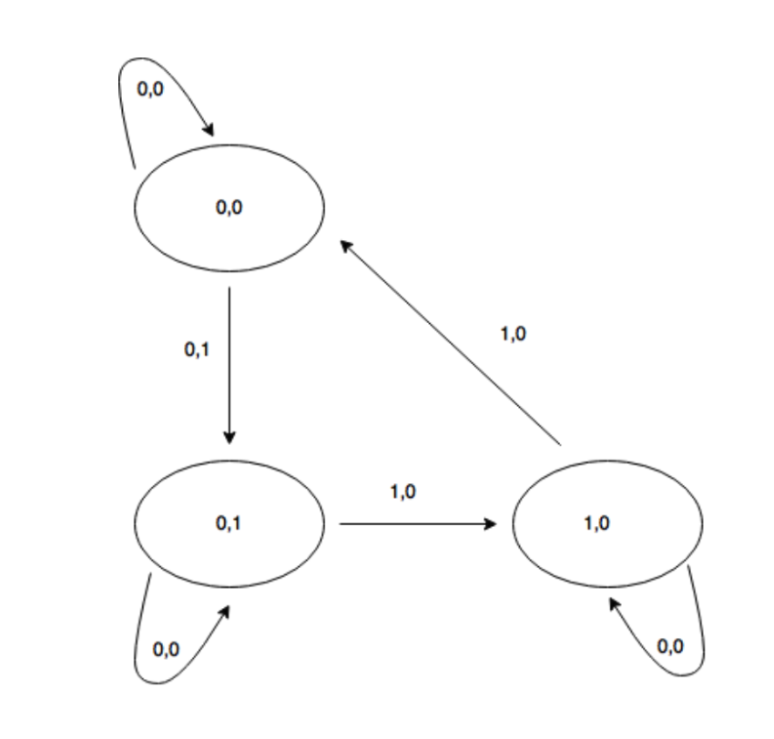

6)

Ja = X, Ka = B’

Jb = X, Kb = A

|  |  |  |  |  |  |  |  |  |
| --- | --- | --- | --- | --- | --- | --- | --- | --- |
| X | A(t) | B(t) | Ja | Ka | Jb | Kb | A(t+1) | B(t+1) |
| 0 | 0 | 0 | 0 | 1 | 0 | 0 | 0 | 0 |
| 0 | 0 | 1 | 0 | 0 | 0 | 0 | 0 | 1 |
| 0 | 1 | 0 | 0 | 1 | 0 | 1 | 0 | 0 |
| 0 | 1 | 1 | 0 | 0 | 0 | 1 | 1 | 0 |
| 1 | 0 | 0 | 1 | 1 | 1 | 0 | 1 | 1 |
| 1 | 0 | 1 | 1 | 0 | 1 | 0 | 1 | 1 |
| 1 | 1 | 0 | 1 | 1 | 1 | 1 | 0 | 1 |
| 1 | 1 | 1 | 1 | 0 | 1 | 1 | 1 | 0 |

State Table:

A)

K-Maps:

|  |  |  |  |  |
| --- | --- | --- | --- | --- |
| A(t+1) | 00 | 01 | 11 | 10 |
| 0 | 0 | 0 | 1 | 0 |
| 1 | 1 | 1 | 1 | 0 |

A(t+1) = XA’ + AB

|  |  |  |  |  |
| --- | --- | --- | --- | --- |
| B(t+1) | 00 | 01 | 11 | 10 |
| 0 | 0 | 1 | 0 | 0 |
| 1 | 1 | 1 | 0 | 1 |

B(t+1) = XB’ + A’B

State Equations:

A(t+1) = XA’ + AB

B(t+1) = XB’ + A’

B)

State Diagram:

